1

St. Margaret Mary’s Catholic Junior School

Knowsley Metropolitan Borough Council ● St. Margaret Mary’s Catholic Junior School ● Pilch Lane ● Liverpool ● L14 0JG
Telephone: 0151 477 8490 email: stmargaret@knowsley.gov.uk
____________________________________________________________________________________________________
Value of the Week  Courage | Newsletter Issue 16  Week ending Friday 19th January 2024

‘……..in God I trust and I am not afraid…..’
Psalms:56:3-4
Congratulations!

Congratulations to Olivia (Y4) who has successfully auditioned for a role of Marta in ‘The Sound of Music’ at the Liverpool Empire Theatre in May. Families may remember how brilliantly Olivia portrayed the title role of Matilda in last year’s school production.
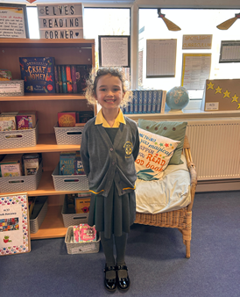

Congratulations to Hana in 6LT who has been fundraising for Share Knowsley, raising a whopping £90! We are very proud of you Hana!
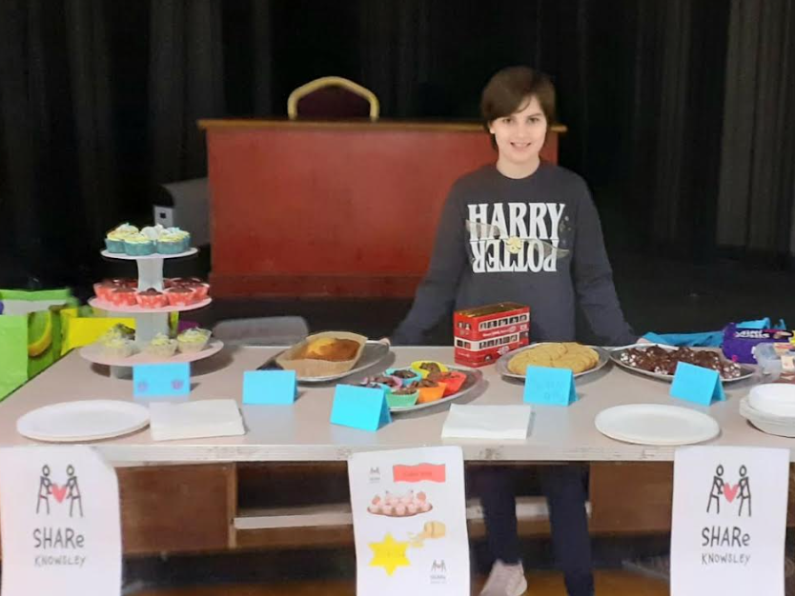

Congratulations to Martha in 5AH who performed a solo of ‘Quiet’ on stage from her favourite musical ‘Matilda’ at the weekend!
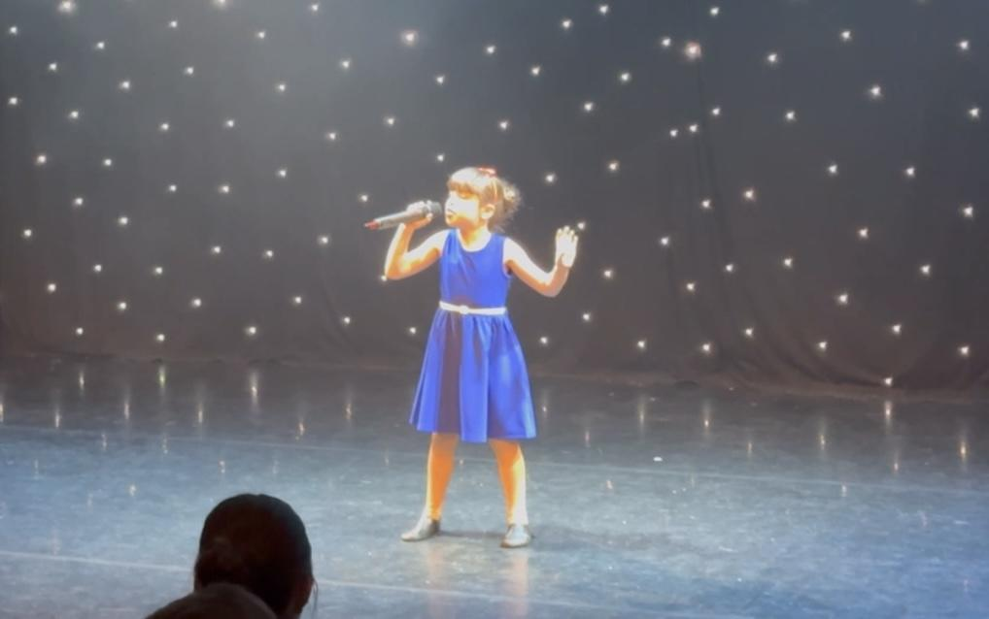

Theatre Cafe

Congratulations to all this week’s performers from the Theatre Café

PHOTO OF PERFORMERS

Andy Grant
This week our Keystage pupils benefited from a very inspirational talk led by amputee Andy Grant.

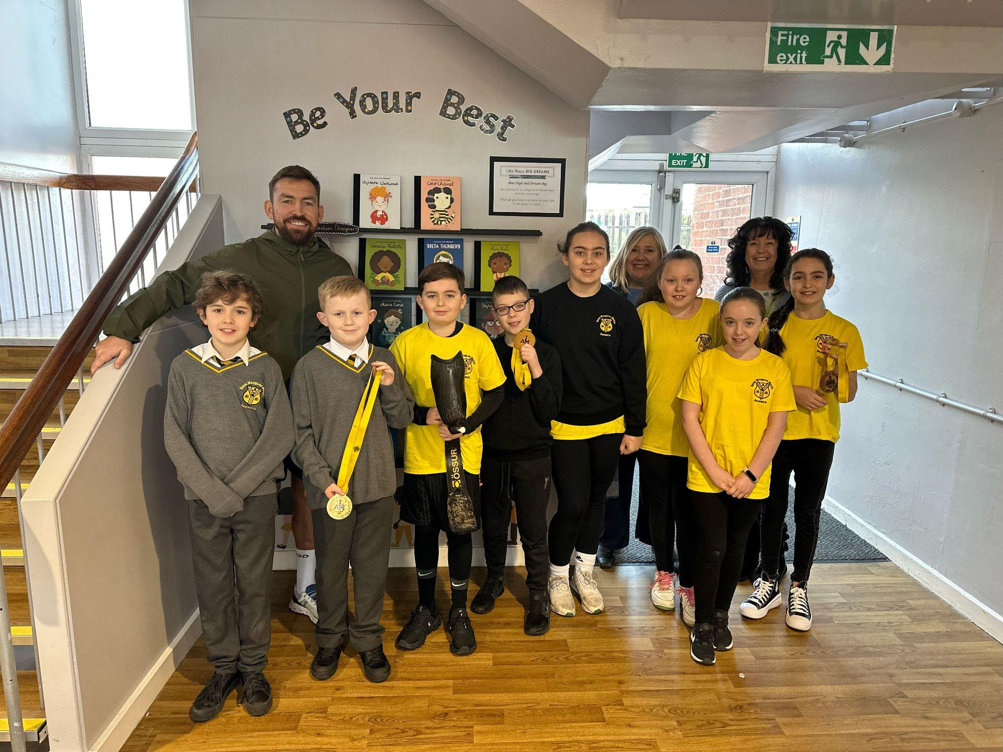

Award Winners
Congratulations to all our award winners this week:-
Class | Certificate of Achievement | Disciple of the Week * | Growth Mindset Award | Attendance Figure  (Please refer to key later in the newsletter)
3CF | Bailey | Freddie | Gabriella | 94.6%
3GT |  |  |  | 91.1%
3HM |  |  |  | 95%
3ST |  |  |  | 96.6%
4CD | Maisie | Noah | Joshua | 90.3%
4HW | Bobby | Abi | Owen | 92.3%
4KH | Emily | Angel | Noah | 92.5%
4SC | Bobby | Niamh | Caitlin | 87.4%
5AH | Emme | Michael | Louie | 91.3%
5JK | Casey | Jennifer | Maria | 93.5%
5KL | Olivia | Isabelle G | Isla | 88.3%
5PS | Jack | Justin | Bella G | 94.7%
6AC | Alex E | Olivia | Carter | 90.4%
6JP | Jamie W | Tyler | George | 93.9%
6LT | Cayden | Evie | Erin | 90.3%
6SA | Oliver | Emily-Grace | Riley | 93.6% |  |  | 96%
Attendance for the whole school is 92.2%
Dinnertime winners:

Times Table Leaderboard
 | Year 3 | Year 4 | Year 5 | Year 6
Highest number of minutes on TTRS | Harry | Karthik | William | Diya
Class with the best engagement | 3HM | 4HW | 5KL | 6AC
Most Improved | Lucia-Ivy | Jake | Alexander | Laura

HOUSE POINTS –
 | YEAR 3 | YEAR 4 | YEAR 5 | YEAR 6 | TOTAL
St Andrew |  | 237 | 254 | 224
St David |  | 213 | 201 | 239
St George |  | 239 | 233 | 225
St Patrick |  | 224 | 240 | 236

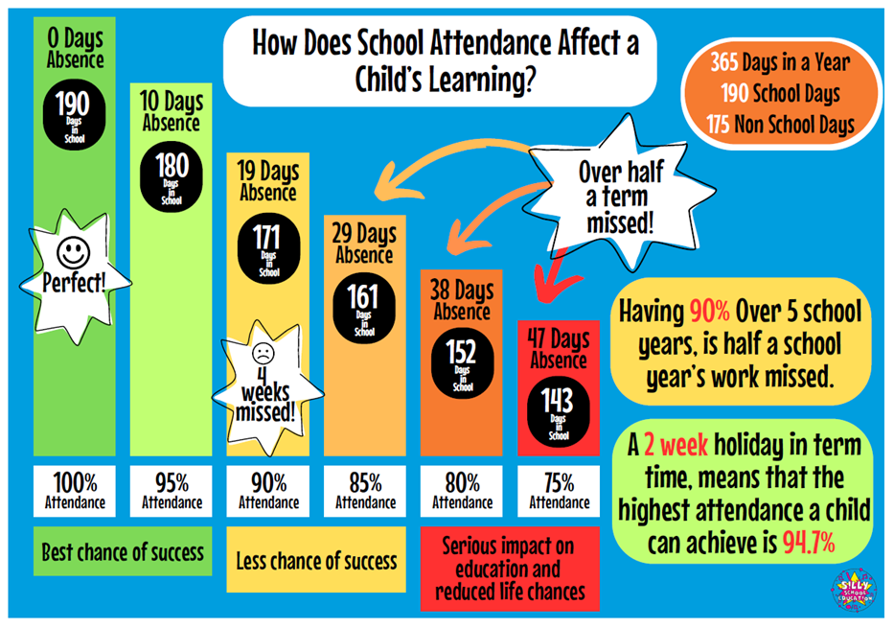
GOVERNOR MORNING
This week some of our school governors came into school to spend time with the children

PHOTO OF SCHOOL GOVERNORS
This week we have launched our bespoke Personal Development Curriculum (named the SHINE curriculum : Safety, Healthy Lifestyles, Independence, News, Equality and Diversity).
The focus of this week’s SHINE lesson has been about keeping safe online. Parents could re-inforce the messages that the children have received this week by chatting to their child about what they have learnt and by directing their child to the following websites:-

https://www.childnet.com/young-people/
https://www.ncsc.gov.uk/collection/top-tips-for-staying-secure-online
SPORT NEWS
Well done to our Year 5 and 6 girls who last week finished runners up in the EFC Premier League competition. The girls won 5 and lost 1, finishing joint top. Sadly, the girls were beaten on goal difference to first place.
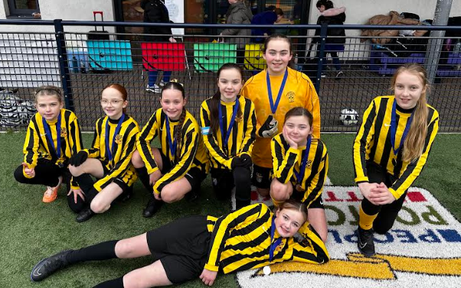
Girls football in St Margaret Mary’s continues to grow, all girls who attend are doing themselves proud!

CLC  Classes 6LT and 6SA are currently benefiting from computing sessions led by the CLC. | SHINE  This week’s SHINE lesson was devoted to ‘Healthy Minds’  The children spent time exploring emotions.
Wellbeing Award Reassessment Visit
We look forward to welcoming a Wellbeing Award assessor into school on Thursday 8th February. We are excited about showing them all that we do to promote the Mental Health & Wellbeing of our school Community. Throughout the visit the assessor will speak to children, staff, the Wellbeing Team and parents. If any of our parents would like to speak to the assessor to share your experiences of support received for your child please speak to Msr Culley or Mrs Perry.
Online Safety Survey
The final piece of data to share from our Online Safety Survey carried out with our children is shown above. Over half of our children would tell a parent or carer if they saw something online that upset them. However, nearly 37% of our children are either unsure or would not report this to parents. Please speak to your children about the importance of reporting anything they see online that they are uncomfortable with. In school we continue to share these important messages with children too through our new SHINE curriculum. (Safety, Health Lifestyles, Independence, News and Equality & Diversity)
SPRING TERM DATES FOR DIARY
Dates are subject to change in certain circumstances-in the case of changes, we will endeavour to give parents as much notice as possible.

January
24th- Boccia Competition
25th-6LT and 6SA to work with the CLC
3GT to Mass

February
1st 6LT and 6SA to work with the CLC
3HM to Mass
Governors’ Buildings, Staffing & Finance Meeting
Year 5/6 Boys’ Huyton League
Change Team Meeting
Week Beginning 5th- Year 3 Child Centred Reviews
6th Safer Internet Day
7th-Year 6 Road Safety
8th Wellbeing Verification Day
6LT and 6SA to work with the CLC
9th-Coffee Morning
Week Beginning 19th-Year 6 Assessment Week
Year 4 Communion Session 4
22nd 6LT and 6SA to work with the CLC
Week Beginning 26th-Year 6 Assessment Week
29th-6AC and 6JP to work with the CLC

March
Week Beginning 4th-Year 5 Child Centred Reviews
5th PTA Meeting
7th World Book Day
Governors’ Curriculum Meeting (5pm)
Week Beginning 11th-Year 4 Holy Communion Session 5
Assertive Mentoring Conversations
14th-British Science Day
Week Beginning 18th-Year 5 trip to Winmarleigh Hall
Assertive Mentoring Conversations
Week Beginning 25th- Assertive Mentoring Conversations

School Clubs

Wake and Shake has been a great success and will now take place in the school hall EVERY morning 8.15am – 8.30am. All children are welcome and are encouraged to come along and start the day with a bit of fun exercise led by Mrs Mills and Miss Devonport. Sometimes Mickey and Minnie even turn up! Infant siblings are allowed to also come along (no toddlers) but must be accompanied by an adult.

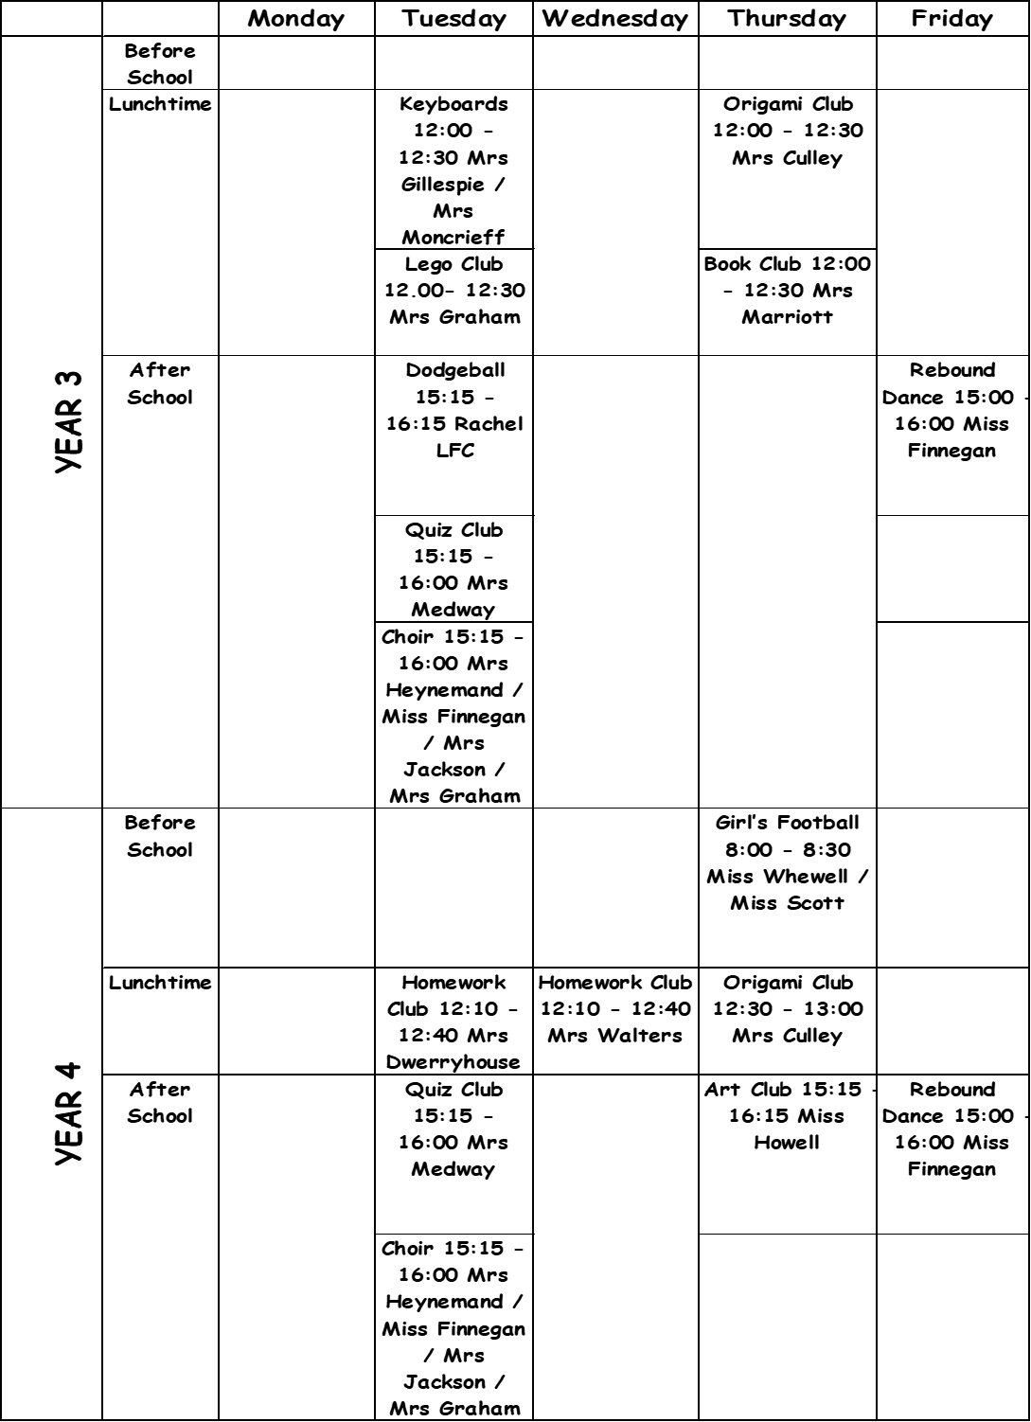
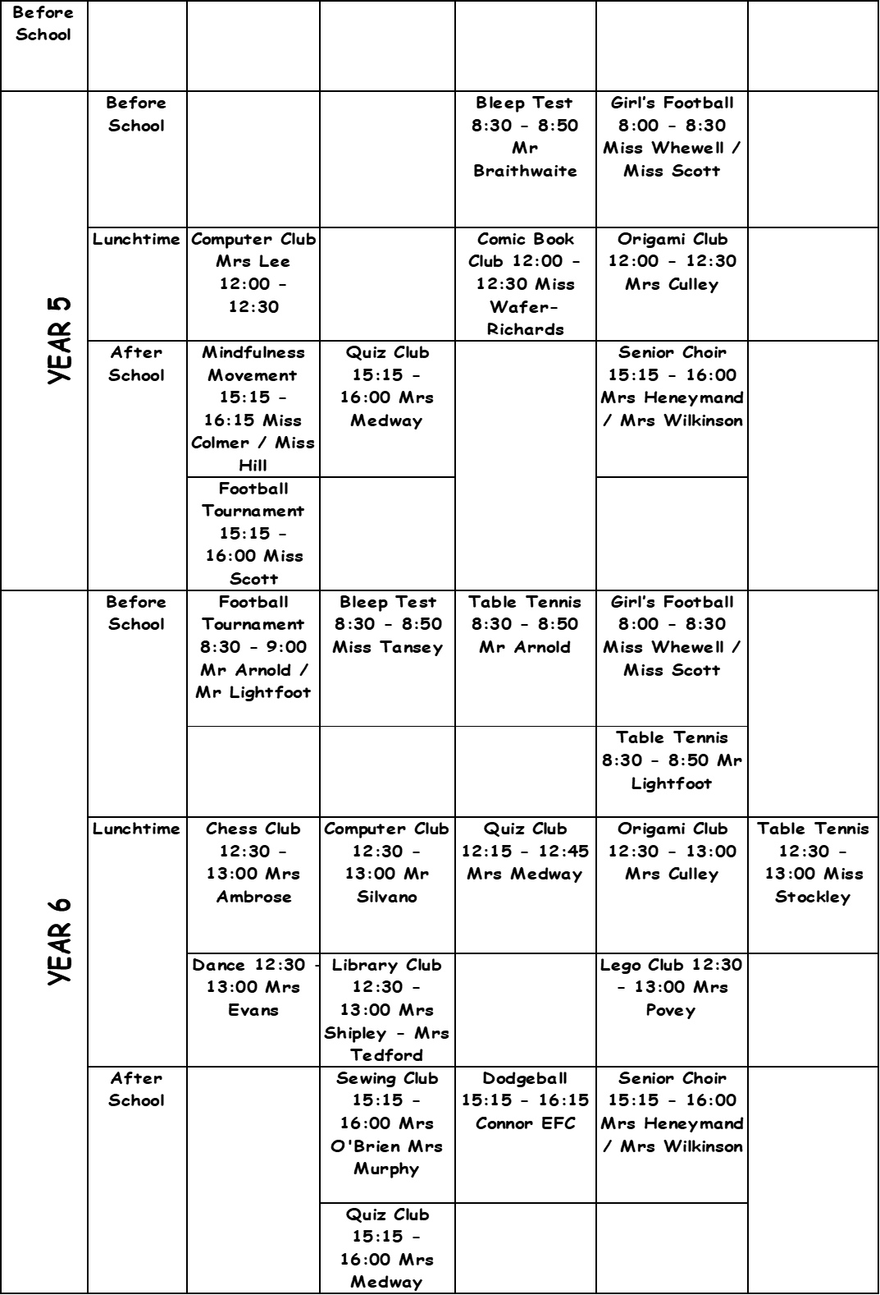

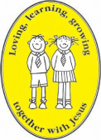
Loving, learning, growing together with Jesus
